Contents
CHAPTER 1 – INTRODUCTION 5
1.1 Introduction 5
1.2 Background 6
1.3 Problem Statement 7
1.4 Limitations: 8
1. Time Constraints: 8
2. Technical Constraints: 8
3. Resource Constraints: 9
4. Testing and Maintenance Constraints: 9
5. Content Moderation Constraints 9
6. University System Integration Constraints 10
1.5 Project objectives 10
1. Facilitate Peer Learning: 10
2. Ensure Secure Student Access: 10
3. Encourage Academic Contribution: 10
4. Centralize Education Resources: 11
5. Enable Structured Q&A System: 11
6. Maintain Quality and Integrity: 11
7. Enhance Student Technical Skills: 11
8. Introduce Account Verification 11
9. Provide a Violation Reporting Page 11
10. Provide Private Learning Sessions 11
11. Encourage Active Participation Through Gamification 12
1.6 Project Solution Overview 12
1.7 Project Scope 13
1. Student Registration and Authentication 13
2. Question & Answer System 13
3. Private Learning Sessions 14
4. Categorization & Content Organization 14
5. Smart Search System 14
6. Points & Rewards System 14
7. Text & Message Moderation 15
8. Image Moderation 15
9. Administrative Dashboard 15
10. User Reporting System 15
11. User Profiles 15
12. Web and mobile platform integration 15
13. Scope Not Covered (Excluded from Version 1): 16
1.8 Project Feasibility 17
1. Technical Feasibility 17
2. Operational Feasibility 17
3. Economic Feasibility 18
4. Schedule Feasibility 18
5. Legal & Ethical Feasibility 18
CHAPTER 2 – LITERATURE REVIEW 20
2.1 Introduction 20
2.2 Review of Existing Systems 21
2.2.1 Piazza 21
2.2.2 Chegg Study 22
2.2.3 Course Hero 23
2.2.4 Reddit Education Communities 24
2.3 Comparison of Existing Solutions 25
2.3.1 Comparative Analysis 25
2.3.2 Identified Gaps and UniConnect’s Position 27
2.3.3 Summary Comparison Table 28
CHAPTER 3 – METHODOLOGY AND WORK PLAN 29
3.1 Introduction 29
3.2 System Development Methodology 30
3.2.1 Why Agile/Scrum? 30
3.2.2 Two-Semester Project Structure 30
3.3 Requirement Gathering Techniques 31
3.4 Project Plan (Gantt Chart) 37
3.4 Project Plan (Gantt Chart) CONT 39
3.4 Project Plan (Gantt Chart) CONT 40
40
3.5 Development of Tools and Technologies 41
3.6 Summary 42
CHAPTER 4 – SYSTEM SPECIFICATION 43
4.1 Introduction 43
4.2 Functional Requirements 43
FR1 – User Registration and Authentication 43
FR2 – User Profile Management 43
FR3 – Academic Post Management 44
FR4 – Academic Request Management 44
FR5 – Points and Reward System 44
FR6 – Search and Content Discovery 44
FR7 – Reporting and Moderation 44
FR8 – Secure Internal Communication 44
FR9 – Administration and System Management 44
FR10 – Mobile Application Integration 45
FR11 – System Logging and Data Storage 45
4.3 Non-Functional Requirements 46
NFR1 – Performance 46
NFR2 – Scalability 46
NFR3 – Security 46
NFR4 – Usability 46
NFR5 – Reliability 46
NFR6 – Maintainability 46
NFR7 – Ethical and AI Considerations 47
CHAPTER 5 – SYSTEM DESIGN 48
5.1 Introduction 48
5.2 System Architecture 48
5.2.1 Architectural Overview 48
5.2.2 Technology Stack 48
5.3 Database Design (ERD) 49
5.3.1 Overview 49
5.3.2 Entity Descriptions 49
5.4 Class Diagram 51
5.5 User Interface Design 53
5.5.1 Design Principles 53
5.5.2 Page Inventory (25 Pages) 53
5.6 Security Design 54
5.7 Points and Rewards System Design 55
5.7.1 Points Transaction Rules 55
5.7.2 Campus Venue Redemptions 56
5.8 Summary 57

CHAPTER 1 – INTRODUCTION

1.1 Introduction
UniConnect is an educational platform designed specifically for university students to promote peer-to-peer learning and collaboration. The platform allows students to request academic help, share explanations, and provide tutoring support for specific courses within their university community. By integrating a points-based reward system and AI-driven moderation, the project aims to create a structured, safe, and motivating digital space for students to exchange knowledge.

The motivation behind this project arises from the growing need for a more interactive, student-centered learning environment that extends beyond traditional classroom boundaries. Many students struggle to find academic support tailored to their university’s curriculum, and existing public platforms often lack relevance, structure, and content quality. UniConnect bridges this gap by connecting students within the same university and ensuring content accuracy through student verification and moderation systems.

In addition to the web-based platform, the UniConnect project also plans to develop a companion mobile application to improve accessibility and ease of use for students. However, the primary focus of the project remains the website, which serves as the core system for all functionalities, data management, and user interactions.

1.2 Background
In recent years, digital education platforms have become a crucial part of academic life. With the increasing reliance on online learning, students often turn to social media groups or generic platforms like YouTube and Reddit for help, but these lack academic structure, proper filtering, and moderation, making it difficult to rely on them for consistent academic support.
Within universities, student collaboration is growing, yet there is no centralized system that enables secure, organized peer-to-peer assistance. This gap inspired the development of UniConnect—a dedicated platform that brings structured collaboration, gamified participation, and AI-supported moderation into one place. Built with ASP.NET, SQL Server, and Azure AI, it provides secure university-based authentication and a scalable backend for managing posts, requests, and communication.

1.3 Problem Statement
University students often face challenges in finding reliable, course-specific academic support within their institution. Current alternatives like WhatsApp or Telegram groups are unorganized, while global learning platforms lack focus on specific university curricula.
This results in:
Unstructured Knowledge Sharing: Current alternatives like WhatsApp or Telegram groups are disorganized, making it difficult to find previously answered questions or quality explanations. Messages get buried, and there's no categorization by course or topic.
Lack of Credibility Verification: Students cannot easily identify who has actually taken and excelled in a specific course, leading to unreliable or incorrect information being shared.
No Quality Control: Without moderation systems, these platforms often contain off-topic discussions, inappropriate content, or spam that distracts from the educational purpose.
Limited Motivation to Help: There is no recognition or reward system that encourages students to actively contribute quality academic content or help their peers.
Privacy and Safety Concerns: Open messaging in informal groups can lead to harassment, spam, or the platform being misused for non-academic purposes.

1.4 Limitations:
Several constraints may influence the project scope, timeline, and achievable outcomes. So, to help set a realistic expectation for the project and development we identified what we think will be a limitation on the project.

1. Time Constraints:
The project is developed by university students alongside academic responsibilities. Deadlines for coursework and exams may limit the available development time.

2. Technical Constraints:
The team has limited experience with large-scale web systems, AI moderation, and database optimization. This affects implementation efficiency, feature complexity, and the integration of AI-based tools that require datasets, computational resources, and specialized knowledge.

3. Resource Constraints:
The project relies on free or limited-access tools (such as free hosting, restricted storage, or basic service tiers). These limitations affect scalability, performance, and the ability to implement advanced features like reward systems or verification tools that may require additional resources or funding.

4. Testing and Maintenance Constraints:
Ensuring continuous testing, server maintenance, and long-term updates is challenging without dedicated funding or stable university-level support. Limited access to official student verification systems or required administrative approval may also impact the reliability and design of the authentication process.

5. Content Moderation Constraints
The platform aims to maintain a purely academic environment by preventing off-topic or inappropriate conversations, especially within private learning sessions. However:
- Implementing effective AI-based content moderation requires significant computational resources and advanced natural language processing capabilities.
- Rule-based moderation systems may not catch all forms of inappropriate content or creative attempts to bypass filters.
- Balancing strict moderation with user privacy and natural conversation flow presents ongoing challenges.
The project will start with rule-based text and image moderation, with the possibility of expanding to more
advanced AI-based systems depending on available resources and testing results. Video content moderation
is not included in the initial version.

6. University System Integration Constraints
The platform requires university ID-based authentication to verify student enrollment. However:
- No access to the university's official database means the system cannot automatically verify student IDs against the institution's records.
- Alternative verification methods will be needed, such as requiring students to use their official university email during registration, manual approval by administrators, or document verification.
- This limitation affects the speed and automation of the registration process and may require additional administrative oversight.

1.5 Project objectives
The Edu-Connect platform aims to address the lack of structured peer-to-peer learning among university students by providing a secure, interactive, and rewarding digital space for knowledge exchange. And for that we gathered the main objectives.

1. Facilitate Peer Learning:
Develop an online platform that enables students to request and provide academic help in specific subjects or topics within the university community.

2. Ensure Secure Student Access:
Implement a university ID-based authentication system to verify that only enrolled students can register and interact on the platform.

3. Encourage Academic Contribution:
Introduce a measurable Points System that tracks user activity and reward helpful contributions such as explanations, post, or helpful feedback.

4. Centralize Education Resources:
Build a Categorized database and a search function that allows students to easily find pervious explanations, materials, or discussions related to their courses.

5. Enable Structured Q&A System:
Implement a question-and-answer system where:
- Students post questions as public posts
- Other students respond through comments (text and images)
- A search system allows searching for previously answered questions
- Content is organized by faculty, course, and topic

6. Maintain Quality and Integrity:
Utilize an AI-based or rule-driven moderation system to ensure that shared content is academic, respectful, and relevant.

7. Enhance Student Technical Skills:
Provide the student development team with hands-on experience in full-stack web development, teamwork, and system design within real project constraints.

8. Introduce Account Verification
Establish a Verification Tier System, where users who achieve a certain number of points or consistently provide high-quality contributions receive a Verified Tutor Badge.

9. Provide a Violation Reporting Page
Implement a dedicated Report Page that allows students to report inappropriate behavior or content they encounter on the platform.

10. Provide Private Learning Sessions
Create a secure one-on-one learning environment where:
- Students can request private tutoring sessions with knowledgeable peers
- Sessions activated only after mutual agreement from both parties
- Communication is limited to educational purposes through monitored messaging
- Sessions have defined time limits and structured completion processes

11. Encourage Active Participation Through Gamification
Introduce an engagement system that rewards students based on:
- Quality answers and helpful contributions
- Consistency through streak systems
- Positive ratings from peers
- Overall community involvement

1.6 Project Solution Overview
The UniConnect platform will be developed using ASP.NET Core, SQL Server, and modern web technologies to provide a structured, curriculum-aligned academic support system for university students.
The system includes a Question & Answer module where students post academic questions organized by faculty, course, and topic. Other students respond through comments with text and images, and all content remains searchable for future reference.
To support deeper learning, UniConnect offers Private Learning Sessions, enabling students to request one-on-one tutoring directly from posts or user profiles. Sessions open only after mutual agreement and include secure internal messaging and a structured session lifecycle.
The platform maintains an academic environment through automated rule-based moderation, preventing inappropriate or off-topic content across posts, comments, and private messages.
Engagement is enhanced through gamification features, including a points system, streak tracking, and recognition tools that encourage consistent participation. Community-driven quality control is implemented through upvotes, best-answer marking, and user ratings.
A reporting system allows students to flag violations, while administrators manage reported content, oversee user accounts, and maintain platform organization through an integrated dashboard.
The platform supports advanced search and categorization, user profile pages with contribution statistics, real-time notifications, and a fully responsive design for seamless use across devices.
Alongside the web platform, a mobile application will be developed using the same backend services and APIs to ensure consistency across platforms. The website will remain the central component of the system, while the mobile application will act as a supportive extension that allows students to access key features such as browsing posts, participating in discussions, receiving notifications, and managing private learning sessions.

1.7 Project Scope
The scope of UniConnect defines the features, functionalities, and boundaries that the project will cover during its development. The system is designed to support secure student-to-student academic assistance, content sharing, and structured communication within a single university environment. The scope includes both core features that will be fully implemented and excluded features that may be added in future versions.
Scope Covered:

1. Student Registration and Authentication
- Implementation of a secure login system that requires each user to use their university ID number and password to be able to access the website.

2. Question & Answer System
  - Students post academic questions as public posts
  - Questions displayed in organized feeds by categories
  - Other students respond through comments (text and images)
  - Video support not included in initial version

3. Private Learning Sessions
- Session request functionality available from posts and user profiles
- Sessions require mutual consent from both parties before activation
- Private messaging channel opens upon session confirmation
- Sessions have defined time limits and structured endings
- Mandatory mutual rating system upon session completion

4. Categorization & Content Organization
  - Each faculty/college receives its own structured category.
    - Faculty
    - Course
    - Topic
  - This ensures clean organization and easy browsing.

5. Smart Search System
  - Students can search for:
    - Past explanations
    - Short videos
    - Old requests
    - Notes and summaries

6. Points & Rewards System
  - Students earn points when:
    - Responding to requests
    - Posting explanations
    - Receiving positive ratings
  - Points can be used to:
    - Submit new requests
    - Redeem small rewards (e.g., cafeteria discount)
    - Exchange for university-approved benefits
  - A starting bonus is given at registration.

7. Text & Message Moderation
  - Rule-based filtering systems for posts, comments, and messages
  - Automatic detection of inappropriate or off-topic content
  - Maintains educational focus throughout the platform

8. Image Moderation
  - Review process for uploaded images
  - Ensures images are appropriate and academically relevant

9. Administrative Dashboard
  - Administers (faculty or trusted students) can:
    - Approve flagged posts
    - Manage categories
    - Ban or restrict users violating the rules
    - Review AI moderation logs

10. User Reporting System
  - Report inappropriate posts or comments
  - Flag violations during private sessions
  - Report spam or off-topic content
  - User warning and restriction capabilities

11. User Profiles
  - Profile pages display:
    - Contribution statistics
    - User ratings and reputation
    - Areas of expertise
    - Activity history
    - Achievement indicators

12. Web and mobile platform integration
  - The primary system will be a web-based platform developed using ASP.NET Core.
  - A mobile application will be developed in parallel using the same backend APIs.
  - The mobile application will focus on essential features and usability, while advanced administration and full system management will remain web based.

13. Scope Not Covered (Excluded from Version 1):
- Video content upload and moderation (may be added in future versions)
- Full-featured native mobile applications with complete administrative functionality (the initial mobile app will support core user features only)
- Direct integration with university's official database for automatic ID verification
- Monetary rewards system (points system does not involve real money)
- Multi-university support (initially launching at Philadelphia University only)
- Advanced AI-powered features (such as automatic answer generation or intelligent tutoring)
- Real-time video/audio communication within sessions
- Mobile push notifications (web notifications only initially)
- Content translation or multi-language support

1.8 Project Feasibility
The feasibility assessment evaluates whether the UniConnect platform can be successfully developed, deployed, and maintained using the resources and skillset available to the student development team.

1. Technical Feasibility
Use of Achievable Technologies.
- The system will be built using:
  - ASP.NET Core for backend development
  - SQL Server for database storage
  - Other frameworks related to web-development
Scalability
- SQL Server can handle large numbers of posts and requests.
- ASP.NET supports modular expansion for future updates

2. Operational Feasibility
Alignment with Student Needs
- Students already seek help through unorganized channels.
- UniConnect centralizes and organizes academic assistance inside the university.

3. Economic Feasibility
Low Initial Cost
- The project uses:
  - Free or educational hosting
  - Student developer labor
  - Limited cloud-based AI usage
Cost Control
- Point-based rewards do not require real money in version 1.
Potential Future Revenue/Support
- Partnerships with:
  - University administration
  - Campus services
  - Cafeterias or bookstores
- Could provide rewards or sponsorship.

4. Schedule Feasibility
Time Constraints
- The project timeline must be aligned with:
  - Academic semester schedules
  - Exam periods
  - Availability of the student development team
- A realistic development plan will use milestone-based progress.

5. Legal & Ethical Feasibility
Student Verification
- Ensures only authenticated students access the platform.
- Protects against misuse and external access.
Content Safety
- AI moderation ensures compliance with academic and ethical guidelines.
Privacy
- Chat system is strictly limited and avoids unnecessary personal communication.

CHAPTER 2 – LITERATURE REVIEW

2.1 Introduction
A literature review provides essential context for understanding existing solutions, identifying best practices, and locating gaps that new systems can address. For UniConnect, examining prior educational platforms is crucial to understanding how peer learning, content moderation, user engagement, and academic integrity have been handled in digital academic environments.

This review focuses on four major platforms relevant to UniConnect’s goals—Piazza, Chegg, Course Hero, and Reddit’s education communities. Each represents a distinct approach to academic support. By comparing their design principles, strengths, and limitations, this chapter establishes the foundation for developing UniConnect as a curriculum-aligned, peer-to-peer support platform tailored to university students.

2.2 Review of Existing Systems

2.2.1 Piazza
Overview:
Piazza is a course-based Q&A platform designed to enhance communication between instructors, teaching assistants, and students. It combines discussion forums with editable, wiki-style answers.
Key Features:
- Real-time updates
- LaTeX and code formatting
- Anonymous posting options
- LMS integration (e.g., Canvas, Blackboard)
- Version history and topic-based organization
Strengths:
- Instructor endorsement ensures credibility
- Reduces repetitive email communication
- Encourages collaborative knowledge building
- High student engagement
- Analytics support for instructors
Weaknesses:
- Effectiveness depends heavily on instructor involvement
- Content is restricted to current courses and semesters
- Limited peer recognition mechanisms
- Some features are shifting to paid models
- No private tutoring or mentoring options
- Limited cross-course search
Academic Integrity:
Generally strong due to instructor oversight, but still vulnerable to homework-solution requests.

2.2.2 Chegg Study
Overview:
Chegg is a subscription-based homework assistance platform offering textbook solutions, expert Q&A, and tutoring. Its model emphasizes rapid expert responses rather than peer collaboration.
Key Features:
- Large library of step-by-step textbook solutions
- Expert Q&A (2–4-hour response time)
- Math solver
- AI-based learning tools
- Mobile apps and personalized dashboards
Strengths:
- Extensive coverage across subjects
- Fast, expert-level responses
- 24/7 availability
- Detailed explanations promote understanding
Weaknesses:
- High cost creates accessibility issues
- Widely used for academic dishonesty
- Solutions are generic and may not match specific curriculum methods
- No peer interaction or learning community
- Quality inconsistency, especially with AI-generated responses
- Privacy concerns in university investigations
Academic Integrity:
Chegg poses significant integrity risks, as many students use it to obtain assignment answers rather than learn concepts.

2.2.3 Course Hero
Overview:
Course Hero is a document-sharing platform hosting over 60 million study resources contributed by students and educators. It includes paid tutoring and AI-based assistance.
Key Features:
- Institution-organized document library
- AI homework assistance
- 24/7 tutoring
- Math-solving tools
- Contribution-based unlock system
- Mobile access and offline availability
Strengths:
- Vast, diverse content repository
- Incentive system encourages user contributions
- Organized by school and course
- Supports multiple learning formats
Weaknesses:
- Frequent copyright violations
- Significant academic integrity issues
- Content accuracy is inconsistent
- Complicated content removal processes
- Unlock/paywall model frustrates users
- Potential privacy risks
- No systematic expert verification
Academic Integrity:
Course Hero is heavily criticized for enabling cheating and hosting unauthorized copyrighted materials.

2.2.4 Reddit Education Communities
Overview:
Reddit hosts many education-related subreddits (e.g., r/HomeworkHelp, r/College). While not designed for academic support, these communities offer peer interaction through voting, anonymity, and community moderation.
Key Features:
- Upvote/downvote ranking
- Anonymous participation
- Volunteer moderation
- Post flair for topic tagging
- Threaded discussions
- Awards and recognition
Strengths:
- Free and accessible
- Fast responses in active communities
- Authentic peer perspectives
- Long-term searchable discussion archives
- Covers both academic and personal student needs
Weaknesses:
- No curriculum alignment
- No verification of expertise
- Disorganized and inconsistent content quality
- Tone may be unhelpful or hostile
- Moderation varies widely
- No long-term mentoring relationships
- Risk of distraction and exposure to inappropriate content
Academic Integrity:
Integrity standards vary by subreddit. Some communities attempt to prevent cheating, while others do not.

2.3 Comparison of Existing Solutions

2.3.1 Comparative Analysis
Platform Purpose:
- Piazza: Structured, instructor-led collaboration
- Chegg: Paid expert solutions
- Course Hero: Crowdsourced study resources
- Reddit: Open, anonymous peer discussion
- UniConnect: University-specific peer learning and tutoring
Curriculum Alignment:
- Piazza: High (course-specific)
- Chegg: Low
- Course Hero: Medium
- Reddit: None
- UniConnect: High (university-wide, multi-semester)
Quality Control Approaches:
- Piazza: Instructor moderation
- Chegg: Expert network (declining with AI)
- Course Hero: Peer ratings
- Reddit: Voting and community moderation
- UniConnect: AI filtering + peer ratings + session evaluations
Engagement Models:
- Piazza: Instructor analytics
- Chegg: Paid access
- Course Hero: Contribution-based unlocks
- Reddit: Karma and awards
- UniConnect: Points, streaks, ratings, leaderboards

Accessibility and Cost:
- Piazza: Mostly free
- Chegg: High cost
- Course Hero: Freemium
- Reddit: Free
- UniConnect: Fully free to university students
Academic Integrity:
- Piazza: Generally low risk
- Chegg/Course Hero: Very high risk
- Reddit: Variable
- UniConnect: Integrity-focused design prioritizing explanation over answers

2.3.2 Identified Gaps and UniConnect’s Position
Gap 1: Curriculum-Aligned Peer Support
Existing platforms fail to provide long-term, institution-specific support across semesters.
UniConnect fills this by offering university-wide, curriculum-aligned peer assistance.
Gap 2: Free, Quality-Controlled Learning
Free platforms lack quality; quality platforms are expensive.
UniConnect provides free access with strong quality controls.
Gap 3: Sustainable Motivation Systems
Platforms either rely on instructors, payments, or generic karma systems.
UniConnect uses structured gamification (points, ratings, streaks) within the university context.
Gap 4: Structured Peer Tutoring
No free platform offers in-depth, one-on-one peer mentoring.
UniConnect integrates private sessions with accountability mechanisms.
Gap 5: Academic Integrity by Design
Most platforms are answer-focused, creating opportunities for cheating.
UniConnect prioritizes explanation, understanding, and moderated peer interactions.

2.3.3 Summary Comparison Table

Feature | Piazza | Chegg | Course Hero | Reddit | UniConnect
Curriculum Alignment | High | None | Medium | None | High
Cost | Free | High | Freemium | Free | Free
Quality Control | Instructor | Experts | Peer ratings | Voting | Peer Ratings
Private Tutoring | No | Paid | Paid | No | Yes (free)
Academic Integrity | Good | Poor | Poor | Variable | Strong
Institution Specificity | High | None | Medium | None | Full

CHAPTER 3 – METHODOLOGY AND WORK PLAN

3.1 Introduction
This chapter outlines the methodology and work plan adopted for the development of the UniConnect platform. It provides a detailed explanation of the software development lifecycle, the requirement gathering techniques, and the project timeline. Given the scope of the project and its division into two academic semesters (Project 1 and Project 2), the methodology emphasizes flexibility, iterative development, and effective team collaboration.
In addition to the web-based platform, a mobile application will be developed alongside the website to enhance accessibility and user engagement. However, the primary focus of the project remains on the design, implementation, and functionality of the web platform, which serves as the core system of UniConnect.

3.2 System Development Methodology
The team has selected the Agile/Scrum methodology as the primary development model for UniConnect.

3.2.1 Why Agile/Scrum?
Agile/Scrum was selected as the development methodology for the UniConnect platform because it aligns well with the nature, scale, and constraints of the project. The system is being developed by a team of university students, which requires a flexible and adaptive approach to manage both academic responsibilities and evolving project requirements.
The platform consists of multiple independent but connected features, such as user authentication, posts, points management, reporting, requests, and moderation. Agile/Scrum allows these features to be developed incrementally in short development cycles, enabling the team to deliver usable components early and continuously improve them based on testing results and supervisor feedback.
Additionally, the project requirements are expected to evolve as the team gains a deeper understanding of user needs. Agile/Scrum supports this reality by allowing requirement adjustments between sprints without disrupting the entire development plan. This is particularly important for features such as points-based verification, which may require experimentation and gradual refinement.
Traditional sequential models such as the Waterfall model were not chosen because they require fixed requirements from the beginning and offer limited flexibility for changes.

3.2.2 Two-Semester Project Structure
To align with the university’s curriculum, the development is divided into two major phases:
- Phase I (Project 1 - Design & Planning): Focuses on problem identification, literature review, requirement specification, database architecture, and UI/UX prototyping for the web platform. In addition, high-level planning and interface design for the mobile application are prepared to ensure consistency between both platforms.
- Phase II (Project 2 - Implementation & Testing): Focuses on full-stack development of the web platform, implementation of core features, system testing, and final deployment. In parallel, the mobile application is developed using the same backend APIs and tested to ensure smooth integration with the web platform.

3.3 Requirement Gathering Techniques
To ensure the platform meets the actual needs of the university student community, the following techniques were employed:
- Comparative Analysis: Reviewing existing educational platforms to identify functional gaps and academic integrity standards.

- Team Brainstorming: Regular sessions among the four team members to define core features such as the private session system and the gamification logic.

- Literature Review: Studying academic research and existing solutions to establish best practices for peer-to-peer learning.

- Completing surveys: Online surveys were conducted among university students to identify academic difficulties and preferred platform features. The results helped validate system requirements and guide feature prioritization.
As shown in these statistics, the findings confirm the need for a structured peer-to-peer learning platform.
Section 1: Basic Information
- 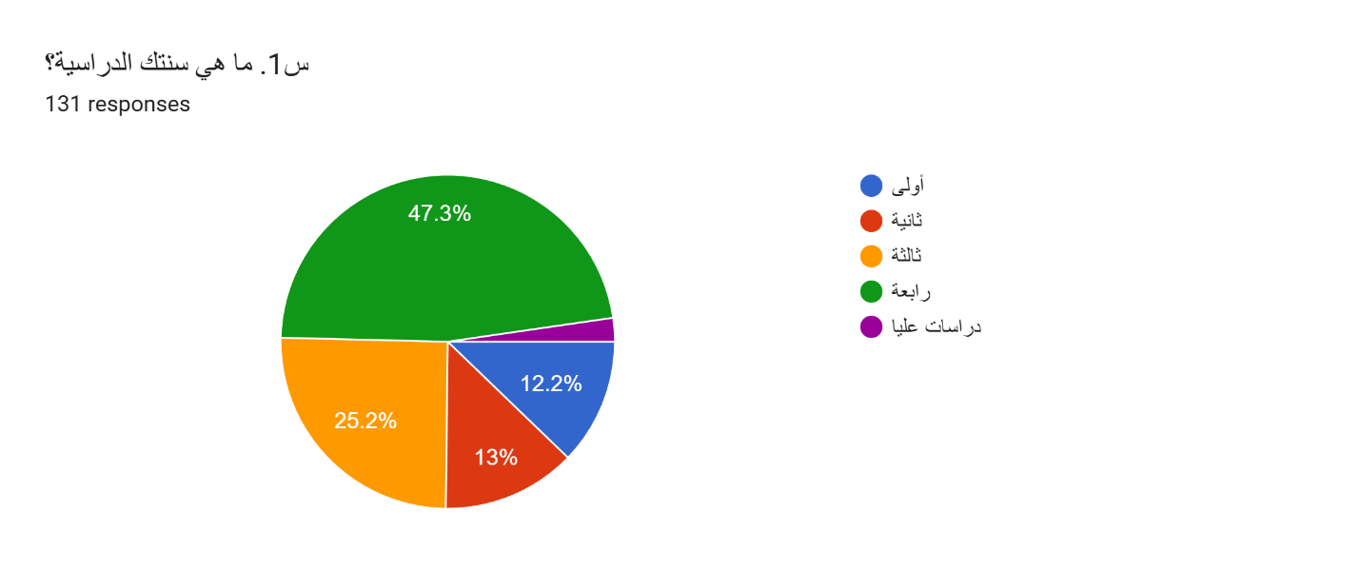
- 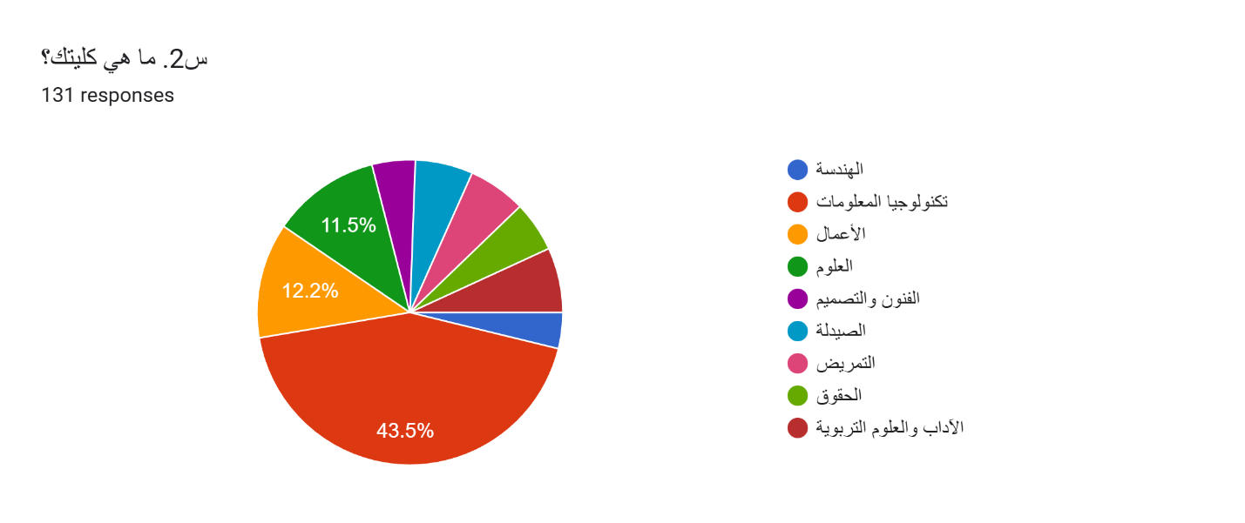

- 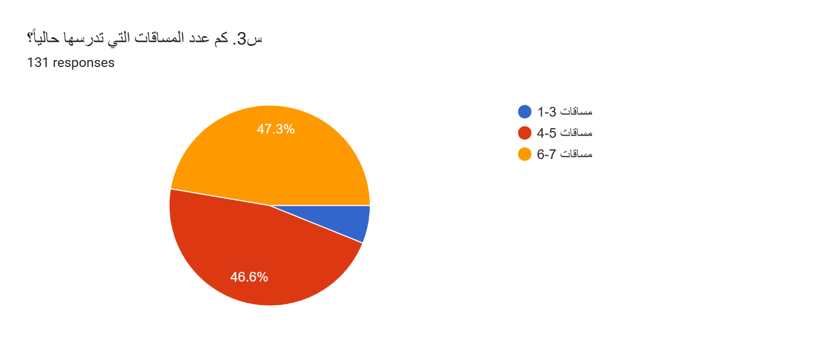
Section Two: Academic Support Habits

- 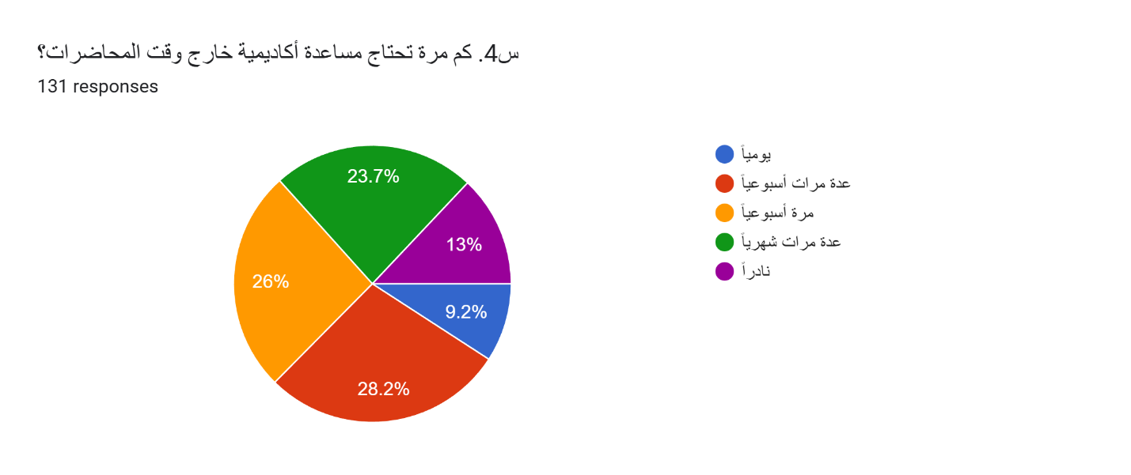
- 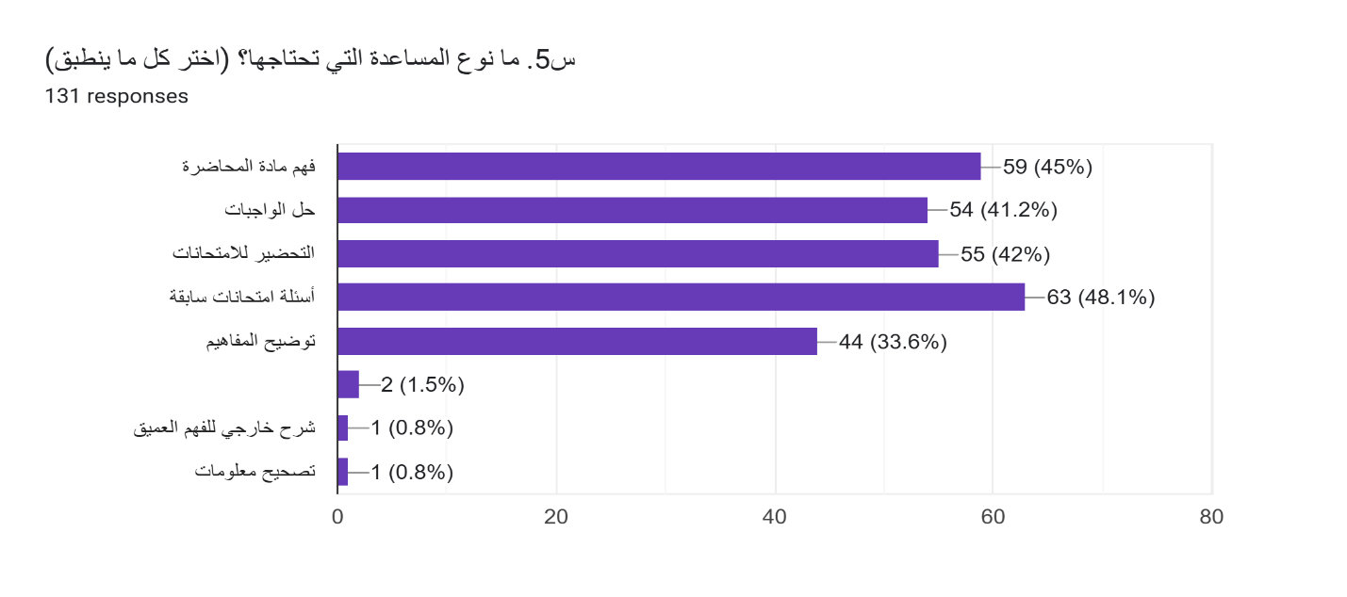

- 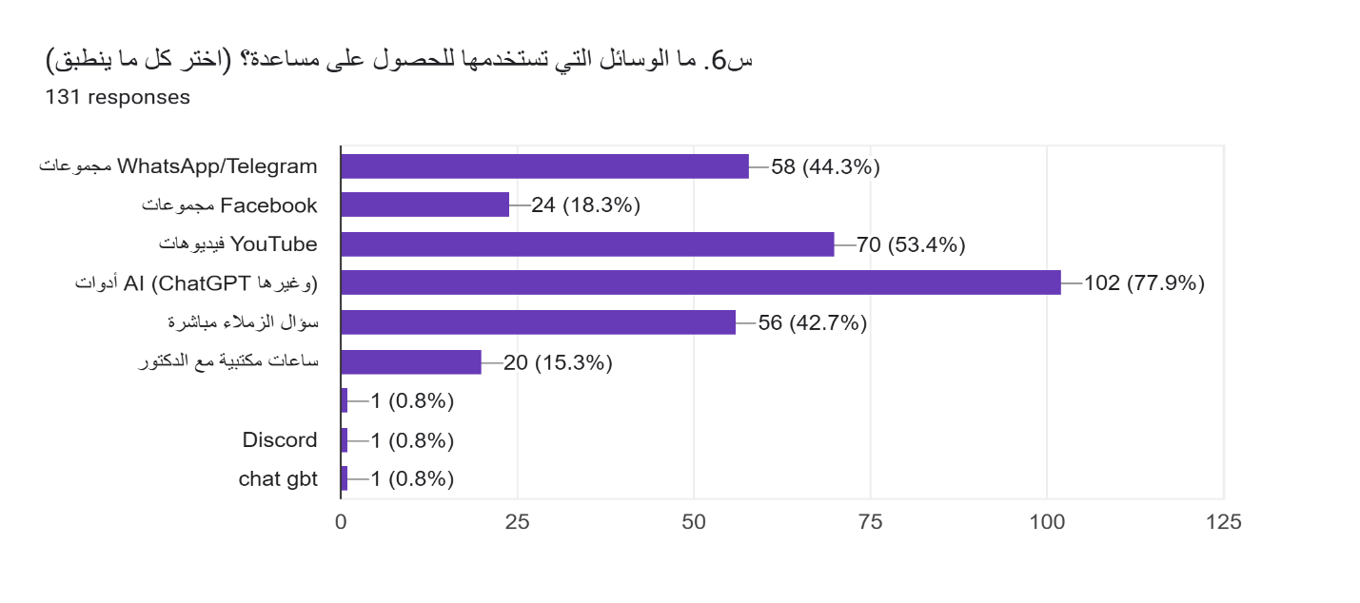

- 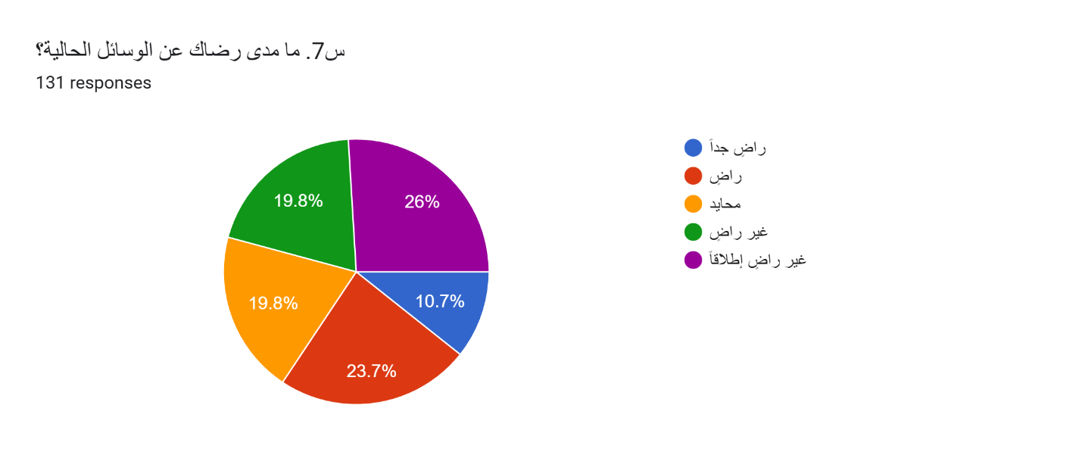
Section Three: Challenges
- 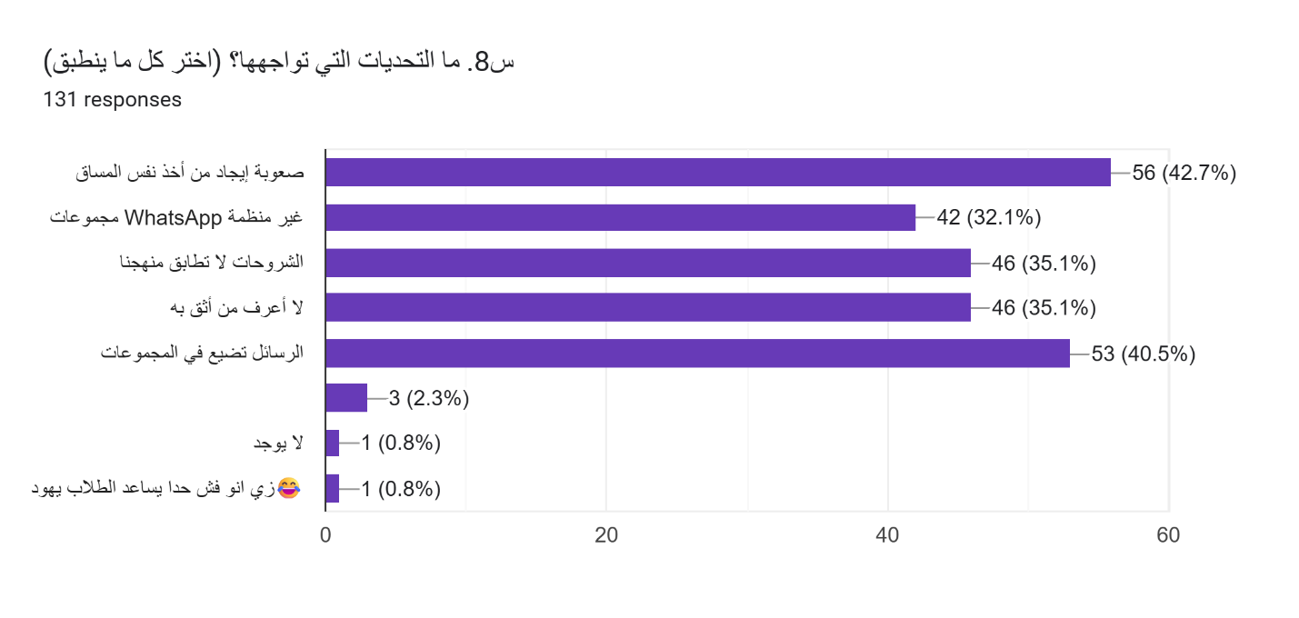

- 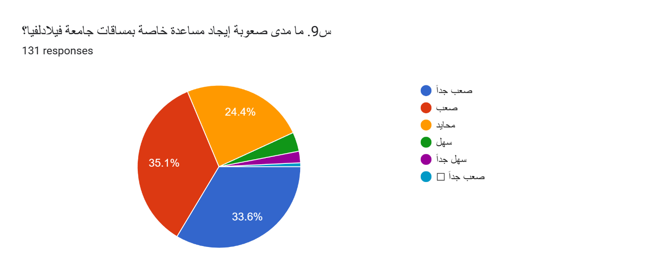

Section Four: Required Features
- 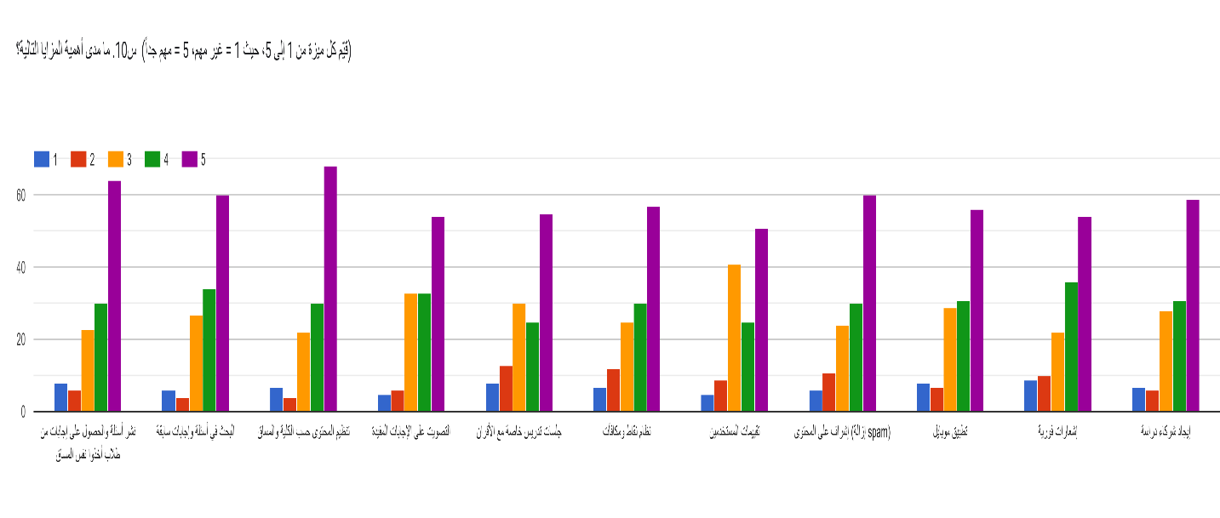
Section Five: UniConnect Platform
- 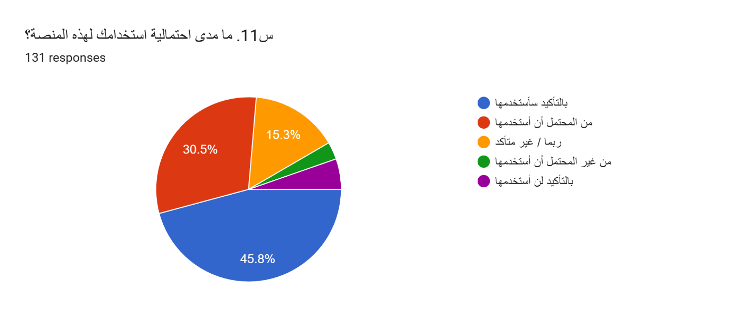
- 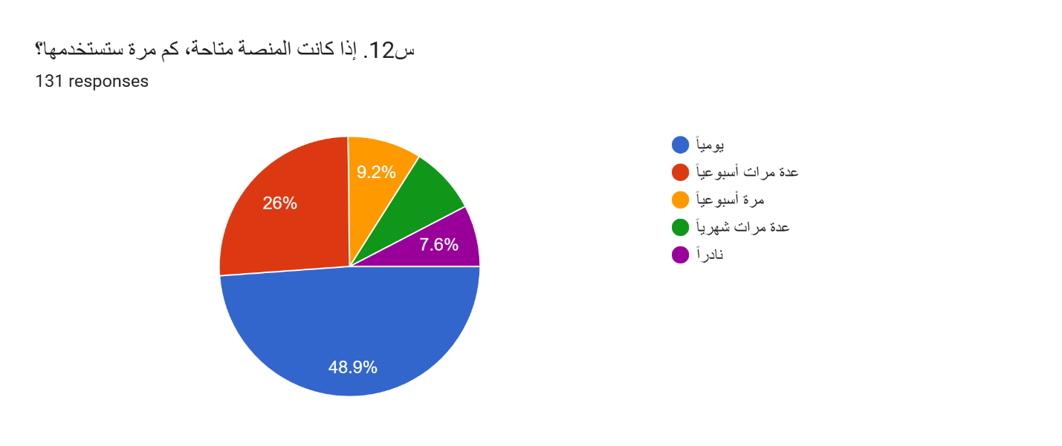

- 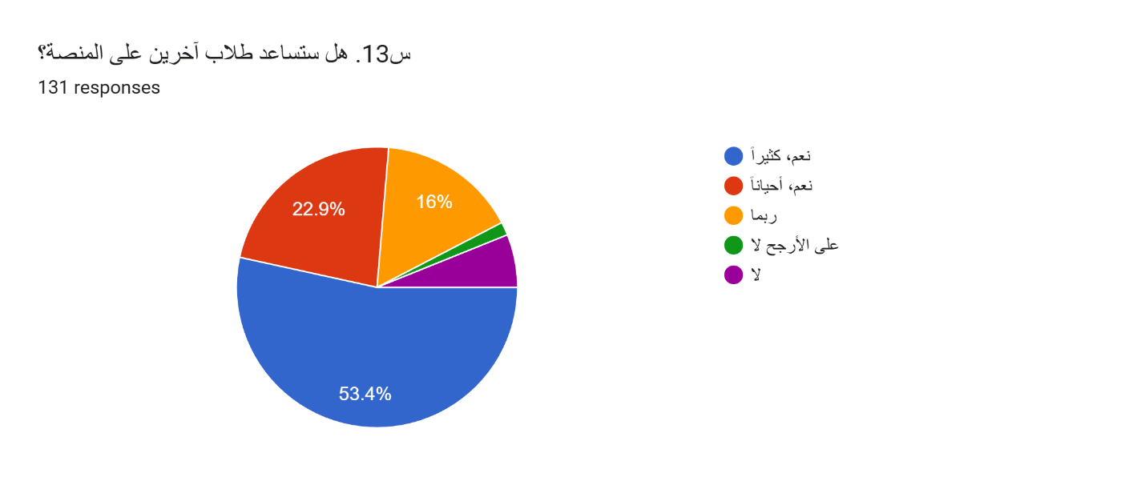

3.4 Project Plan (Gantt Chart)
Literature review & system analysis
The project plan follows a milestone-based progress system aligned with the academic calendar.
Semester 1/ Project 1:
Phase | Activity / Milestone | Semester | Duration
Initiation | Project topic selection & approval | Project 1 | Weeks 1
Planning | Problem definition & objectives | Project 1 | Weeks 1-2
Analysis |  | Project 1 | Weeks 2-4
Requirements | Functional & non-functional requirements | Project 1 | Weeks 4-5
Methodology | Selection of development methodology | Project 1 | Weeks 5
Design | Database design (ERD) | Project 1 | Weeks 6-7
Design | UI/UX wireframes & mockups | Project 1 | Weeks 8-9
Review | Supervisor feedback & refinements | Project 1 | Week 10
Documentation | Project 1 report writing & submission | Project 1 | Week 11–12

Visual representation of the project timeline (Semester 1) in gantt chart:
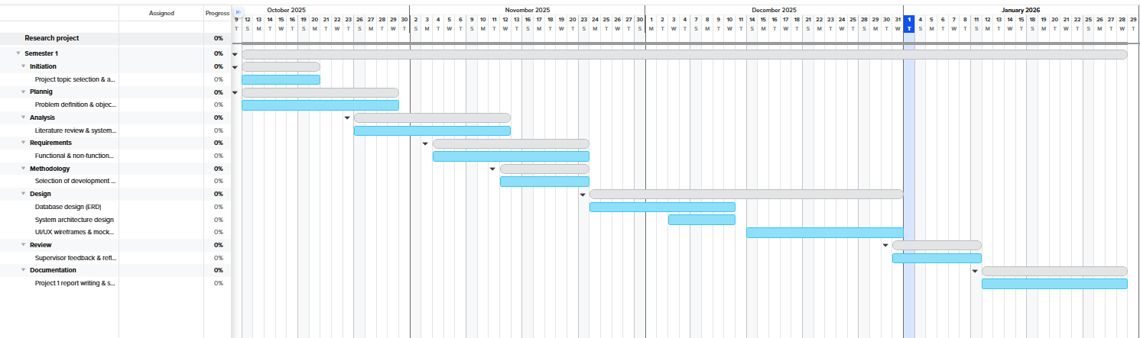
Link : (https://app.teamgantt.com/share/kyWxxl/projects/gantt2)

3.4 Project Plan (Gantt Chart) CONT - Semester 2/ Project 2
Phase | Activity / Milestone | Semester | Duration
Setup | Development environment & tools setup | Project 2 | Week 1
Backend | Authentication & user management | Project 2 | Week 2
Backend | Requests & posts system | Project 2 | Week 3-4
Backend | Points & rewards system | Project 2 | Week 5
Frontend | UI implementation & responsiveness | Project 2 | Week 6
Integration | Secure messaging system | Project 2 | Week 7
Integration | AI text moderation integration | Project 2 | Week 8
Features | Reporting violations & verification badges | Project 2 | Week 9
Testing | Unit testing & bug fixing | Project 2 | Week 10
Testing | User testing & feedback | Project 2 | Week 11
Optimization | Performance & security improvements | Project 2 | Week 12
Deployment | Final deployment & system demo | Project 2 | Week 12
Documentation | Final report & presentation | Project 2 | Week 13
3.4 Project Plan (Gantt Chart) CONT - Semester 2/ Project 2
Visual representation of the project timeline (Semester 2) in gantt chart:
Link : (https://app.teamgantt.com/share/lqV0d4/projects/gantt2)
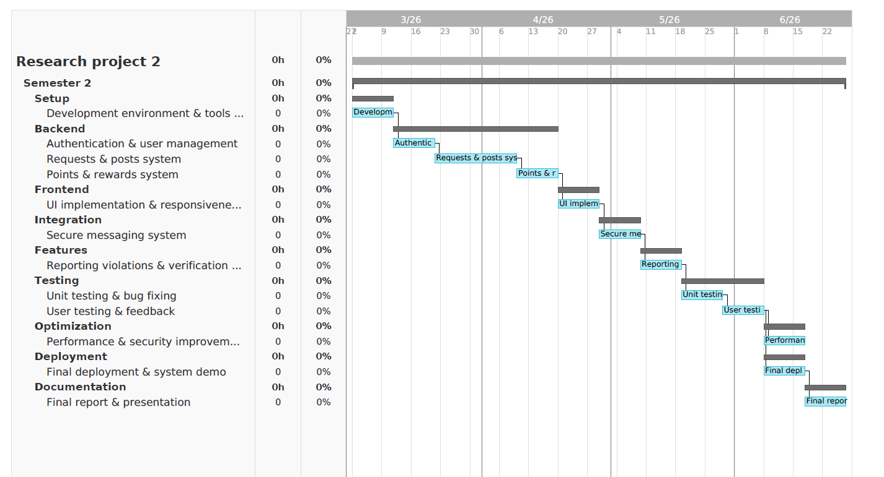

3.5 Development of Tools and Technologies
The technology stack was selected to ensure scalability, security, and responsive user experience.
- Backend Framework: ASP.NET Core (C#) – Used for building robust APIs and modular expansion.

- Database Management: Microsoft SQL Server – To handle structured data and large numbers of posts reliably.

- Frontend UI: HTML5, CSS3, JavaScript, Bootstrap, and Angular– To ensure the platform is responsive for students across different devices.

- Version Control: Git & GitHub – Essential for managing code collaboration among the four team members.

- Content Safety: Automated filtering systems for monitoring inappropriate text and images to maintain a professional academic environment.

- IDE/Code editor: Visual Studio 2022 was chosen for backend development due to its strong support for ASP.NET Core, C#, debugging tools, and integration with SQL Server and Git. Visual Studio Code was used for frontend development because of its lightweight nature, flexibility, and extensive extension support for HTML, CSS, JavaScript, and Angular.

3.6 Summary
Chapter 3 has defined the roadmap for the UniConnect project. By adopting an Agile methodology and a structured two-semester plan, the team ensures that the design phase in Project 1 provides a solid foundation for the technical implementation in Project 2. The selected tools and techniques are aligned with academic requirements to deliver a secure and curriculum-aligned platform.

CHAPTER 4 – SYSTEM SPECIFICATION

4.1 Introduction
This chapter presents the system specifications for the UniConnect platform, focusing on both functional and non-functional requirements. Functional requirements define the features and operations that the system must support, while non-functional requirements describe how well the system should perform these functions under various conditions. These specifications serve as a foundation for system design, development, testing, and evaluation, ensuring that the platform meets user needs while maintaining acceptable performance, security, usability, and reliability standards.

4.2 Functional Requirements
This section defines the core functional requirements of the UniConnect platform. These requirements describe what the system must do in terms of user interactions, data processing, and system behavior. Each requirement is designed to be clear, testable, and directly linked to the project objectives.

FR1 – User Registration and Authentication
- The system shall allow users to register using a valid university ID.
- The system shall authenticate users using secure login credentials.
- The system shall restrict access to authenticated users only.
- The system shall differentiate user roles (Student, Admin).
- Input: University ID, login credentials
- Process: Credential validation and session creation
- Output: Successful login or error message

FR2 – User Profile Management
- The system shall allow users to view and update their profile information.
- The system shall display the user’s accumulated points and verification status.
- The system shall maintain a personal activity history for each user.

FR3 – Academic Post Management
- The system shall allow users to create, edit, and delete academic posts.
- The system shall categorize posts by faculty, course, or topic.
- The system shall display posts in chronological or relevance-based order.

FR4 – Academic Request Management
- The system shall allow users to submit requests for academic assistance.
- The system shall update request status (Open, Accepted, Closed).

FR5 – Points and Reward System
- The system shall award points for approved academic contributions.
- The system shall deduct points when users submit new requests.
- The system shall track total points for each user.
- The system shall mark accounts as verified once a predefined point threshold is reached.

FR6 – Search and Content Discovery
- The system shall provide a search function for posts and requests.
- The system shall allow filtering by faculty, course, and keywords.
- The system shall display relevant previous content before new submissions.

FR7 – Reporting and Moderation
- The system shall allow users to report inappropriate or non-academic content.
- The system shall record reported content and reasons for review.
- The system shall provide administrators with tools to review and resolve reports.

FR8 – Secure Internal Communication
- The system shall enable private communication only after request approval.
- The system shall restrict messaging to service-related interactions.
- The system shall store message history securely.

FR9 – Administration and System Management
- The system shall allow administrators to manage users, posts, and reports.
- The system shall provide dashboards for monitoring system activity.
- The system shall allow content removal or account suspension when required.

FR10 – Mobile Application Integration
- The system shall provide backend APIs to support a mobile application.
- The system shall ensure consistent functionality between web and mobile platforms.
- The system shall synchronize user data across both platforms.

FR11 – System Logging and Data Storage
- The system shall store all user activities securely in a database.
- The system shall maintain logs for authentication, posts, requests, and reports.
- The system shall ensure data integrity and consistency

4.3 Non-Functional Requirements
This section defines the quality attributes that the UniConnect platform must satisfy to ensure effective operation, user satisfaction, and system sustainability.

NFR1 – Performance
- The system shall respond to user requests within 2 seconds under normal conditions.
- The system shall support at least 200 concurrent users.
- Database queries shall execute within 1 second on average.

NFR2 – Scalability
- The system shall support scalable cloud deployment.
- The database shall support growth without major redesign.
- Backend APIs shall support both web and mobile platforms.

NFR3 – Security
- The system shall enforce authentication and authorization.
- Passwords shall be securely hashed.
- Access shall be role-based.

NFR4 – Usability
- The system shall be easy to use for university students.
- The interface shall be accessible on web and mobile devices.
- Key tasks shall require minimal user interactions.

NFR5 – Reliability
- The system shall handle errors gracefully.
- Data integrity shall be preserved during failures.
- User data shall not be lost during normal operation.

NFR6 – Maintainability
- The system shall use a modular architecture.
- Code shall be documented and maintainable.
- Future features shall be added with minimal refactoring.

NFR7 – Ethical and AI Considerations
- AI moderation shall assist, not replace, human review.
- Users shall be able to report content.
- Admins shall review AI moderation decisions.

CHAPTER 5 – SYSTEM DESIGN

5.1 Introduction
This chapter presents the complete system design of UniConnect, the peer-learning platform built exclusively for Philadelphia University students. The design covers the system architecture, database schema, class diagram, user interface design, security design, and the points and rewards system. All design decisions are grounded in the functional and non-functional requirements established in Chapter 4, and align with the Agile/Scrum methodology described in Chapter 3.
The design follows three core architectural patterns: Layered Architecture for clear separation of concerns, Model-View-Controller (MVC) for the web application structure, and the Repository Pattern for data access abstraction. These patterns ensure the system remains maintainable, testable, and scalable as the user base grows.

5.2 System Architecture

5.2.1 Architectural Overview
UniConnect adopts a three-tier Layered Architecture consisting of the Presentation Layer, Business Logic Layer, and Data Access Layer. This clear separation ensures that changes in one layer do not directly affect others, directly supporting the maintainability requirement (NFR6). The three tiers communicate as follows:
- Presentation Layer: The web browser renders HTML5/CSS3/JS pages. Mobile clients consume the same REST API.
- Business Logic Layer: ASP.NET Core services handle all application rules/authentication, Q&A, points, sessions, search, and moderation.
- Data Access Layer: Repository classes using Entity Framework Core communicate with the SQL Server database.

5.2.2 Technology Stack
The following technology stack was selected based on team expertise, university environment requirements, and the scalability needs of the platform:
Layer | Technology | Justification
Presentation /Frontend | HTML5, CSS3, JavaScript | Universal browser support, no framework dependency required for prototype phase
Application  /Backend | ASP.NET Core (C#) | High performance, strongly typed, excellent for REST API development
Data/Database | Microsoft SQL Server | Enterprise-grade RDBMS, integrates seamlessly with the .NET ecosystem
ORM | Entity Framework Core | Reduces boilerplate data access code, supports database migrations
Authentication | JWT Tokens | Stateless, secure, supports both web and mobile clients (FR1)
Version Control | Git / GitHub | Team collaboration, branching strategy aligned with Scrum sprints
Table 5.1: UniConnect Technology Stack

5.3 Database Design (ERD)

5.3.1 Overview
The UniConnect database is designed using a relational model hosted on Microsoft SQL Server. The schema supports all eleven functional requirements (FR1–FR11) defined in Chapter 4. The database consists of nine primary tables with well-defined primary and foreign key relationships to ensure referential integrity and data consistency (NFR5).

5.3.2 Entity Descriptions
Entity | Primary Key | Description
Users | UserID (INT, PK, IDENTITY) | Stores all registered student and admin accounts
Posts | PostID (INT, PK, IDENTITY) | Academic questions posted by students
Answers | AnswerID (INT, PK, IDENTITY) | Responses to posts with upvote tracking and best answer flag
Sessions | SessionID (INT, PK, IDENTITY) | Private tutoring sessions between two students
Messages | MessageID (INT, PK, IDENTITY) | Chat messages exchanged within a private session
Points | TransactionID (INT, PK, IDENTITY) | Log of all points earned and spent per user
Reports | ReportID (INT, PK, IDENTITY) | Content moderation reports submitted by users (FR7)
Notifications | NotifID (INT, PK, IDENTITY) | In-platform notifications for all user activity events
Table 5.2: UniConnect Database Entities
- You can also use this link to view the diagram
https://lucid.app/lucidchart/bc030b5f-5c6e-4408-9510-94b4c0b3df71/edit?viewport_loc=752%2C-1392%2C1866%2C2442%2C0_0&invitationId=inv_4fe75edf-6ba9-47ad-acc8-e89f7f25b23a

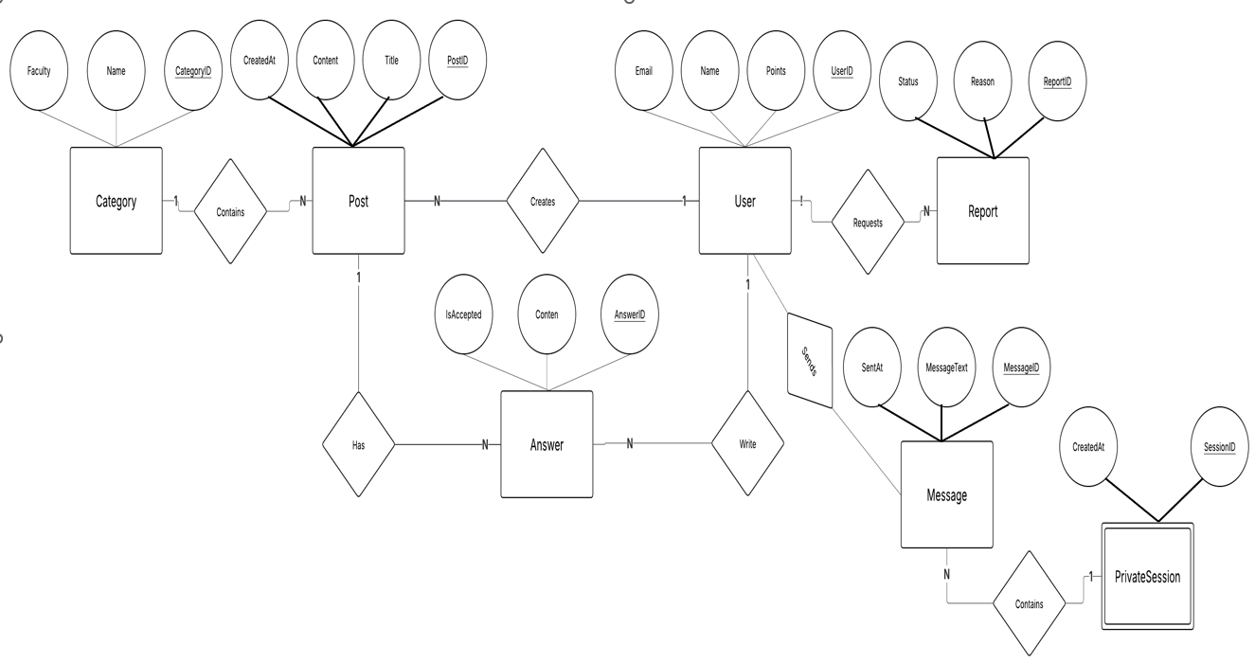

5.4 Class Diagram
The UniConnect backend follows object-oriented design principles. The class structure consists of an abstract BaseEntity class inherited by four primary domain classes: User, Post, Answer, and Session. Three design patterns are applied throughout the system: Singleton (database connection), Observer (notifications), and Repository (data access abstraction).
Pattern | Where Applied | Purpose
Singleton | DbConnectionManager | Ensures a single shared database connection instance throughout the application lifecycle
Observer | NotificationService | Automatically notifies users when events occur: new answers, upvotes, session requests
Repository | All data access classes | Abstracts data access from business logic, enabling unit testing and future database migration
MVC | ASP.NET Core controllers | Separates presentation (API responses), business logic (services), and data models cleanly
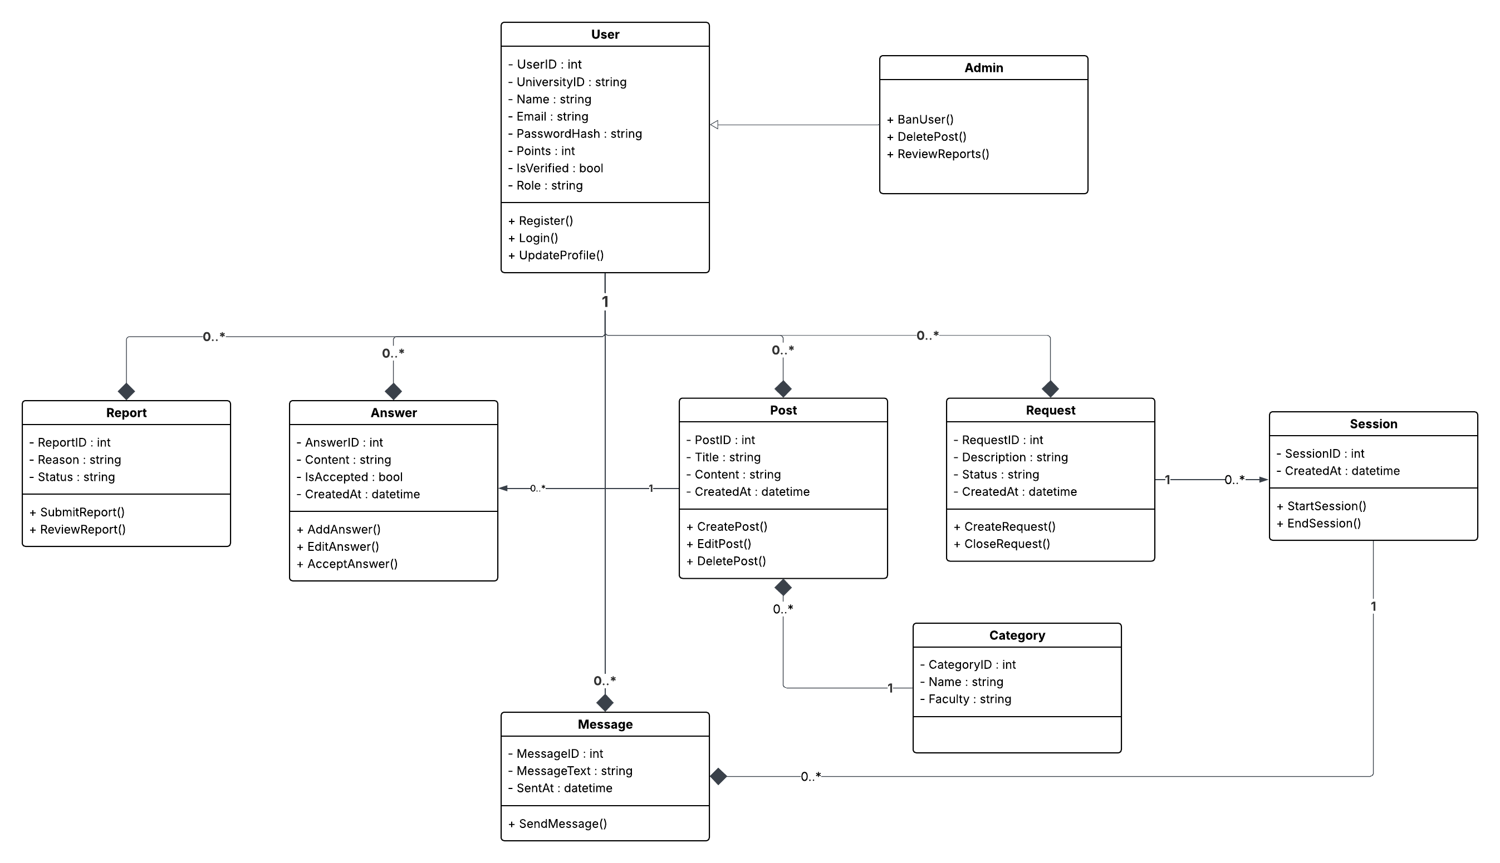
Table 5.3: Design Patterns Applied in UniConnect

- You can also use this link to view the diagram
https://lucid.app/lucidchart/dcf7c385-cfd1-48e6-9db3-018dcaa26a21/edit?viewport_loc=400%2C-257%2C3148%2C2794%2C0_0&invitationId=inv_8e64ba1a-a5eb-4545-8db0-7e155940939b

5.5 User Interface Design
(https://www.figma.com/design/VriK6QafriBYw9CPGZvjZ0/1?node-id=0-1&t=kmOXapUcm7Iu8Be5-1)

5.5.1 Design Principles
The UniConnect interface was designed following established UX principles to ensure ease of use for university students across all faculties (NFR4 – Usability). The following five principles guided all design decisions:
- Consistency: All 25 pages share the same navigation structure, color palette, typography, and component library.
- Visual Hierarchy: Important actions use the primary indigo color. Secondary actions use ghost buttons. Destructive actions use red.
- Feedback: Every action provides immediate visual feedback — toast notifications, loading indicators, form validation messages, and character counters.
- Accessibility: Minimum contrast ratios maintained. Form inputs have clear labels and error messages. Navigation functions with keyboard.
- Responsive Design: All pages are fully responsive. The sidebar collapses into a hamburger drawer on screens below 768px width.

5.5.2 Page Inventory (25 Pages)
# | File Name | Page Name | Requirement
1 | index.html | Landing Page (visitors) | Public marketing page
2 | login.html | Sign In | FR1
3 | register.html | Register | FR1
4 | register-success.html | Email Verification Sent | FR1
5 | forgot-password.html | Forgot Password | FR1
6 | reset-password.html | Reset Password | FR1
7 | dashboard.html | Home Feed | FR3, FR6
8 | create-post-step1.html | Ask — Step 1: Search First | FR3, FR6
9 | create-post-step2.html | Ask — Step 2: Write Question | FR3
10 | create-post-step3.html | Ask — Step 3: Preview & Post | FR3
11 | create-post-step4.html | Ask — Step 4: Success | FR3, FR5
12 | single-post.html | Question Detail + Answers | FR3, FR4
13 | profile.html | My Profile | FR2
14 | user-profile.html | Other User Profile | FR2
15 | sessions.html | Private Sessions + Chat | FR4, FR8
16 | leaderboard.html | Leaderboard | FR5
17 | notifications.html | Notifications | FR11
18 | points.html | Points & Campus Rewards | FR5
19 | settings.html | Settings | FR2
20 | search-results.html | Full Search Results | FR6
21 | report-content.html | Report Content | FR7
22 | admin.html | Admin Dashboard | FR9
23 | admin-user-detail.html | Admin User Detail | FR9
24 | 404.html | Page Not Found | NFR4
25 | create-post.html | Ask a Question (combined) | FR3
Table 5.4: UniConnect 25-Page Inventory

5.6 Security Design
Security is enforced at every layer of the UniConnect architecture, aligned with NFR3. The following measures are implemented to protect user data and prevent unauthorized access:
Security Area | Measure | Implementation
Authentication | JWT Bearer Tokens | Stateless tokens with expiry issued on login, validated on every API request
Passwords | BCrypt Hashing | Passwords never stored in plain text; BCrypt with salt applied before database storage
Authorization | Role-Based Access Control | Student vs Admin roles enforced at controller level; admins cannot access student-only endpoints
SQL Injection | Parameterized Queries | Entity Framework Core uses parameterized queries by default, preventing SQL injection attacks
University Access Lock | Email Domain Validation | Only @philadelphia.edu.jo email addresses accepted at registration (FR1)
Table 5.5: UniConnect Security Measures

5.7 Points and Rewards System Design
The Points and Rewards System (FR5) is a central feature of UniConnect that incentivizes academic contribution. Every transaction is atomic — points are always awarded or deducted as a unit and every transaction is logged in the Points table for full auditability. When a student redeems a venue reward, the system: (1) verifies sufficient balance, (2) deducts the points atomically, (3) generates a unique QR code, and (4) sends it to the student’s university email.

5.7.1 Points Transaction Rules
Action | Points | Trigger
Register new account | +50 | One-time welcome bonus
Post an answer | +5 | Answer submitted to any question
Receive an upvote on answer | +10 | Per upvote received
Answer marked as Best Answer | +15 | Question owner selects best answer
Accept a tutoring session | +20 | Session accepted and completed
Receive 5-star session rating | +15 | Tutee rates the session 5/5
Daily login | +2 | First login of each calendar day
Post a question | −10 | Question submitted to platform
Request a tutoring session | −5 | Session request sent to a tutor
Table 5.6: Points Transaction Rules

5.7.2 Campus Venue Redemptions
Venue | Discount | Cost (pts) | Location
University Cafeteria | 10% off any meal | 200 | Main Building, G/F
University Library | 5 JD credit | 400 | Library Bldg, Level 2
Campus Bookshop | 15% off purchases | 350 | Student Centre, L1
Print & Copy Centre | 20 free A4 pages | 150 | IT Building, Room 102
Student Canteen | Free hot drink | 180 | Engineering Building
Sports & Gym Centre | 1 week free access | 500 | Sports Complex
Computer Lab Booking | 2 hours free access | 100 | IT Building, Lab 3
Extended Library Access | Stay until midnight (1 month) | 300 | Library Building
Verified Tutor Badge | Platform badge + privileges | 1000 | Profile badge
Table 5.7: Campus Partner Venues and Redemption Costs

5.8 Summary
This chapter presented the complete system design of UniConnect across six key areas:
- System Architecture: A three-tier Layered Architecture with ASP.NET Core backend, SQL Server database, and HTML/CSS/JS frontend using MVC and Repository patterns.
- Database Design: Nine relational tables covering users, posts, answers, sessions, messages, points, redemptions, reports, and notifications.
- Class Diagram: Object-oriented design with BaseEntity abstract class, four primary domain classes, and four applied design patterns.
- User Interface Design: 25 self-contained HTML pages organized into five functional groups, built on a consistent design system with full responsive layout.
- Security Design: Multi-layer security including JWT authentication, BCrypt password hashing, role-based access control, parameterized queries, and university email restriction.
- Points System: A gamification engine with seven earn actions, two spend actions, and nine campus venue redemption options with full transaction logging.
The design decisions in this chapter directly address all functional requirements (FR1–FR11) and non-functional requirements (NFR1–NFR7) established in Chapter 4. The backend implementation using ASP.NET Core and SQL Server is scheduled for completion by April 25, 2026.

